PROJECT PROPOSAL
Blockchain-Based Invoice Management
and Payment Authentication System
A secure web-based platform for invoice entry, payment-status verification, duplicate journal number prevention, and Hyperledger Fabric audit recording.
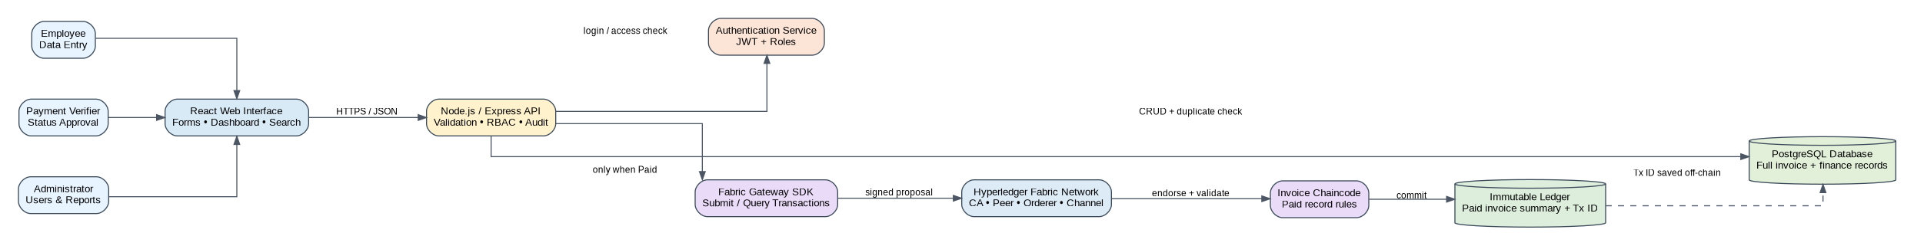
Figure 1. High-level system architecture overview.
Item | Details
Prepared for | Invoice and Payment Management System Development
Prepared by | Ngawang Gyeltshen
Core Technology | React/Web Interface + Node.js/Express API + PostgreSQL + Hyperledger Fabric
Main Users | Employees, payment verification staff, administrators, and auditors
Main Purpose | To record invoice data, verify payment status, prevent duplicate journal numbers, and store verified paid invoice records securely on a permissioned blockchain
Document Date | 24 May 2026

Document Control
Version | Date | Prepared by | Description
1.0 | 24 May 2026 | Ngawang Gyeltshen | Professional expanded proposal with architecture, data, workflow, security, deployment, and testing diagrams.

Executive Summary
This proposal presents a professional design for a web-based invoice management and payment authentication system. The system allows employees to enter invoice, client, journal, and financial data through a structured web form. It then separates ordinary invoice data entry from payment verification so that only authorized staff can confirm whether a payment is Paid, Unpaid, or Pending. Once an invoice is verified as Paid, a summarized tamper-resistant record is written to Hyperledger Fabric, while the full operational details remain in PostgreSQL for business use.
The proposed solution is designed to reduce duplicate journal numbers, improve traceability of payment senders and verifiers, strengthen audit control, and support both Bhutanese and foreign client records. The architecture uses a browser-based frontend, a Node.js/Express backend API, a PostgreSQL relational database, role-based authentication, and Hyperledger Fabric chaincode for verified paid invoice records.
Core business value
The system gives the organization one controlled place to manage invoice records, payment status, employee actions, and blockchain audit references. This reduces spreadsheet dependency, manual confusion, repeated journal numbers, and weak evidence trails.

1. Research Background and Rationale
Invoice management is an important part of financial control because every invoice connects client information, payment confirmation, journal entries, and financial reporting. When invoice records are handled through spreadsheets, paper files, email threads, or disconnected systems, the organization can face repeated entries, unclear ownership, inconsistent payment status, and difficulty proving who entered or verified a record.
E-invoicing and digital recordkeeping improve the consistency and traceability of business information systems by making invoice data structured, searchable, and easier to validate. For organizations serving Bhutanese and foreign clients, a digital platform also makes it easier to separate client categories, store tax and contact details, and filter records by country, status, journal number, and payment history.
Blockchain is suitable for this project because paid invoices require strong audit evidence. A blockchain ledger can provide an append-only record where verified paid entries are traceable and difficult to alter without detection. Hyperledger Fabric is selected because it is permissioned, enterprise-focused, and designed for business networks where participants are known and access can be controlled. PostgreSQL is used for complete operational data because invoice forms, financial fields, client details, and audit logs require flexible querying and relational integrity.

2. Problem Statement
The organization needs a controlled system where employees can enter invoice and financial data, but the current process does not fully solve important payment and record-management risks. Staff may not always know who sent a payment, who verified the payment, whether the journal number has already been used, or whether the invoice should be treated as Paid, Unpaid, or Pending.
Manual processes increase the risk of duplicate journal number entry, double record creation, incorrect payment status, missing payment references, and weak audit control. These risks become more serious when invoice records include financial details such as capital cost, financing cost, working capital, project cost, cash flow statements, profit and loss accounts, capital structure, and cash flow analysis.
Therefore, the organization requires a secure web-based invoice system that separates general invoice entry from payment-status verification, blocks repeated journal numbers, records employee actions, and stores verified paid invoice summaries in Hyperledger Fabric for tamper-resistant audit tracking.

3. Aim of the Project
The aim of this project is to develop a secure web-based invoice and payment authentication system that allows employees to enter invoice data, enables authorized payment staff to update payment status, prevents duplicate journal number entry, and records verified paid invoices on Hyperledger Fabric.

4. Project Objectives
- To create an employee-friendly invoice form for entering client, invoice, journal, payment, and financial data.
- To prevent duplicate journal number entry using automatic backend validation and a database uniqueness constraint.
- To support Bhutanese and foreign client records with clear client classification.
- To allow only authorized staff to update payment status as Paid, Unpaid, or Pending.
- To store only verified Paid invoice summaries on Hyperledger Fabric using the journal number as a key reference.
- To record who entered the invoice, who verified the payment, what changed, and when the action happened.
- To provide a dashboard for searching invoices by journal number, client name, date, payment status, employee, and blockchain transaction reference.
- To reduce manual errors, double entries, payment confusion, and weak audit evidence.

5. Project Scope

5.1 In Scope
- Employee login and role-based access control.
- Invoice, client, journal, finance, and payment data entry forms.
- Duplicate journal number validation before saving records.
- Payment-status update workflow for authorized verification users.
- PostgreSQL database for complete operational records.
- Hyperledger Fabric chaincode for verified paid invoice summaries.
- Audit log for create, update, status change, blockchain submission, and correction activities.
- Dashboard search, filter, status summary, and blockchain transaction reference display.
- Basic reports for paid, unpaid, pending, and blockchain-committed invoices.

5.2 Out of Scope for First Version
- Automatic bank integration unless banking APIs are approved.
- Full accounting software replacement.
- Advanced predictive analytics and AI anomaly detection.
- Public blockchain storage of confidential invoice data.
- Permanent deletion of blockchain records after commitment.

6. Stakeholders and User Roles
Role | Main Responsibility | Access Level
Employee / Data Entry User | Enter client, invoice, journal, finance, and initial payment information. | Create and view own or assigned records; cannot verify Paid status unless authorized.
Payment Verification Staff | Review payment evidence, sender details, payment method, and payment references. | Can update status to Paid, Unpaid, or Pending and trigger blockchain submission for Paid invoices.
Administrator | Manage users, roles, master data, configuration, and system-level reports. | Full administrative access with audit accountability.
Auditor / Reviewer | Review invoice history, status changes, blockchain transaction IDs, and audit logs. | Read-only access to records and reports.
System / Chaincode | Enforce duplicate references and store verified paid invoice summaries. | Automated business-rule execution.

7. Functional Requirements
ID | Requirement | Description | Priority
FR-01 | User authentication | Users must log in using authorized credentials before accessing the system. | High
FR-02 | Role-based access | The system must separate employee, verifier, administrator, and auditor permissions. | High
FR-03 | Invoice entry | Employees must be able to enter client, invoice, journal, finance, and payment-related fields. | High
FR-04 | Duplicate journal check | The system must block saving if a journal number already exists. | High
FR-05 | Payment status update | Authorized staff must update status as Paid, Unpaid, or Pending. | High
FR-06 | Blockchain submission | Only Paid and verified invoices must be submitted to Hyperledger Fabric. | High
FR-07 | Transaction reference storage | The blockchain transaction ID must be stored in PostgreSQL and shown on the dashboard. | High
FR-08 | Search and filters | Users must search/filter by journal number, client, date, status, and transaction ID. | Medium
FR-09 | Audit trail | The system must record who created, updated, verified, or corrected each invoice. | High
FR-10 | Reports | The system should generate status, audit, and blockchain-committed invoice reports. | Medium

8. Non-Functional Requirements
Category | Requirement
Security | Use HTTPS, password hashing, JWT sessions, role-based access, secure environment variables, and audit logging.
Integrity | Journal number must be unique in the database and must not be overwritten after blockchain commitment.
Privacy | Only necessary paid invoice summary fields should be written to blockchain; sensitive full details remain in PostgreSQL.
Availability | System should support regular backups, restore procedures, and containerized deployment.
Performance | Dashboard search should remain responsive through indexing on journal number, client, status, and dates.
Scalability | Architecture should support adding more users, more organizations, or additional Fabric peers later.
Maintainability | Backend services should be modular: auth, invoice, payment, audit, and blockchain gateway services.
Usability | Forms should use clear labels, validation messages, dropdowns for fixed values, and simple status indicators.

9. Data Captured in the System
Data Category | Example Fields | Storage
Client Information | Client name, client type, Bhutanese/foreign classification, contact details, organization name, country. | PostgreSQL
Invoice and Journal Information | Invoice ID, unique journal number, invoice date, invoice amount, currency, description. | PostgreSQL; summary to Fabric only if Paid
Cost and Finance Data | Capital cost, long-term amortization, financing cost, working capital, project cost. | PostgreSQL
Financial Statements | Cash flow statement, profit and loss account, supporting remarks. | PostgreSQL
Project Finance Analysis | Capital structure, cash flow estimates, terminal cash flow, cash flow analysis. | PostgreSQL
Payment Data | Payment sender, date, method, reference, amount received, verification remarks, status. | PostgreSQL; selected proof summary to Fabric when Paid
Blockchain Data | Fabric transaction ID, block number/reference, chaincode response, submitted date, submitted by. | PostgreSQL + Fabric ledger
Employee Audit Data | Entered by, verified by, status updated by, date/time, IP/device metadata if required. | PostgreSQL audit log

10. Proposed System Workflow
Figure 2. Controlled invoice and payment verification workflow.
- Employee logs in using an authorized account.
- Employee enters invoice, client, journal, finance, and payment details through a structured form.
- The backend validates mandatory fields, data types, payment status values, and user permission.
- The backend checks the journal number against PostgreSQL. If the journal number already exists, the submission is blocked.
- If validation passes, the invoice is saved with a default status of Pending or Unpaid.
- An authorized payment verifier reviews payment evidence and updates the status.
- If the invoice is marked Paid, the backend prepares a paid invoice summary and submits it to Hyperledger Fabric through Fabric Gateway.
- Hyperledger Fabric endorses, orders, validates, and commits the transaction through chaincode rules.
- The Fabric transaction ID and chaincode response are stored in PostgreSQL and attached to the invoice record.
- If the status remains Pending or Unpaid, the invoice stays only in PostgreSQL and is not written to blockchain.

11. Proposed System Architecture
Figure 3. Detailed application, database, and blockchain architecture.
The system uses a layered architecture so that user interaction, business logic, database storage, and blockchain recording remain separated. This makes the solution easier to test, maintain, and upgrade.
Layer | Component | Responsibility
Presentation Layer | React.js or HTML/CSS/JavaScript web interface | Provides forms, dashboards, search pages, payment status screens, and simple user feedback.
API Layer | Node.js with Express.js | Receives requests, validates data, applies business rules, checks permissions, and connects to database and Fabric.
Data Layer | PostgreSQL | Stores full invoice, client, finance, payment, audit, user, and blockchain reference data.
Blockchain Layer | Hyperledger Fabric | Stores verified paid invoice summaries as immutable business records.
Smart Contract Layer | Fabric Chaincode | Defines rules for creating paid invoice records, preventing duplicate paid journal references, and querying ledger data.
Security Layer | JWT, RBAC, password hashing, Fabric MSP certificates | Controls login, user roles, API access, and blockchain identity.

12. Database Design
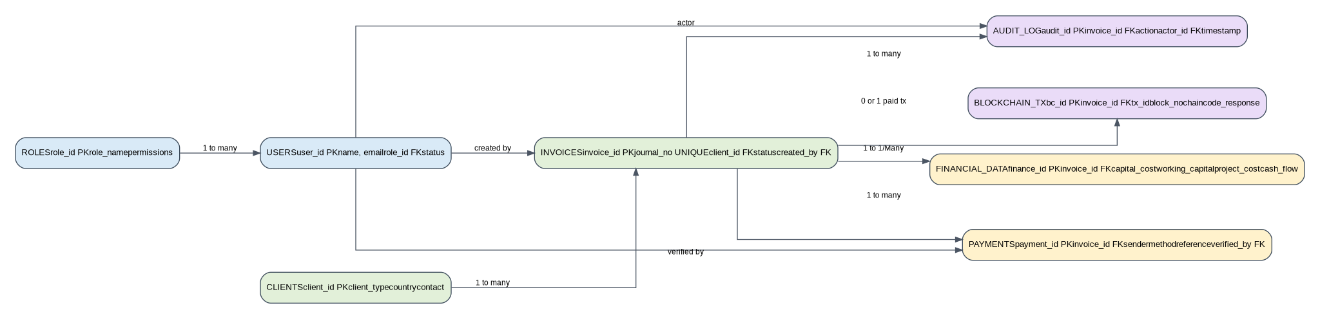
Figure 4. Proposed relational database entity relationship design.
Table | Purpose | Important Notes
users | Stores system users and links them to roles. | Use password hashing and active/inactive status.
roles | Stores role names and permission sets. | Examples: employee, verifier, admin, auditor.
clients | Stores Bhutanese and foreign client details. | Client classification supports reporting and filtering.
invoices | Stores core invoice and journal records. | journal_no must be unique and indexed.
financial_data | Stores cost, finance, statements, and analysis fields. | Can be normalized further if fields become large or repeated.
payments | Stores payment evidence and verification details. | Can store multiple attempts or references for one invoice.
audit_log | Stores every important create/update/status/change action. | Should be append-only in application logic.
blockchain_transactions | Stores Fabric transaction references for paid invoices. | Links database records with blockchain evidence.

13. Payment Status Lifecycle
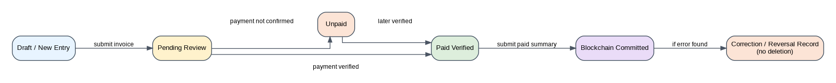
Figure 5. Invoice status lifecycle and correction approach.
The system must avoid uncontrolled changes to payment status. Payment changes should be recorded as events, not silently overwritten. After an invoice has been committed to blockchain, errors should be corrected through a correction or reversal record rather than deleting the ledger entry.
Status | Meaning | Blockchain Action
Pending | Invoice has been created but payment has not yet been fully reviewed. | No blockchain write.
Unpaid | Payment is not confirmed or has not been received. | No blockchain write.
Paid | Authorized verifier confirms payment evidence and sender details. | Submit paid invoice summary to Fabric.
Blockchain Committed | Fabric transaction ID has been returned and stored. | Record is considered tamper-resistant audit evidence.
Corrected / Reversed | A committed record requires correction because of wrong input or later adjustment. | Add correction record; do not delete the original ledger entry.

14. Hyperledger Fabric Design
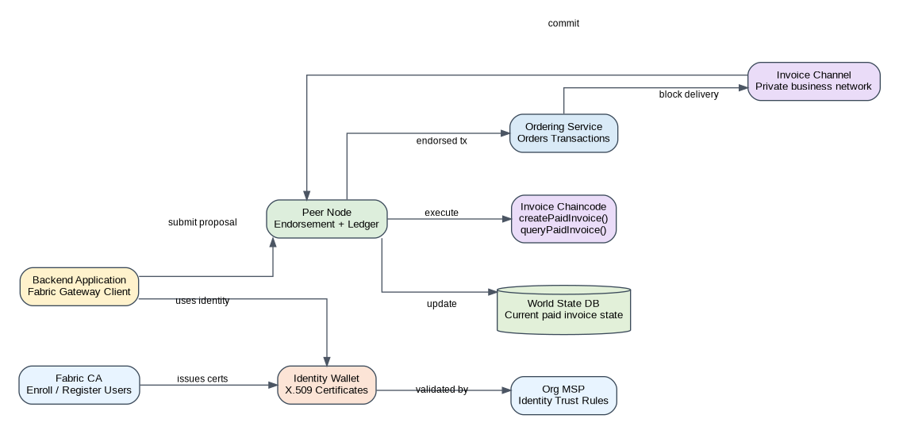
Figure 6. Proposed Hyperledger Fabric network architecture.
Hyperledger Fabric is used only for verified paid invoice summaries. This design keeps confidential and detailed financial data in PostgreSQL while using Fabric for audit-grade payment confirmation evidence.

14.1 Ledger Record Structure
Field | Description
journalNumber | Unique journal number used as the main business key.
invoiceId | Application invoice reference from PostgreSQL.
clientNameHash or clientCode | A privacy-safe client reference where possible.
amount | Invoice amount or paid amount required for audit verification.
currency | Currency of the invoice/payment.
paymentStatus | Must be Paid before chaincode accepts the record.
verifiedBy | Verifier user ID or certificate identity reference.
verifiedAt | Date and time of payment verification.
paymentReferenceHash | Hash of the payment reference or evidence, not necessarily the full sensitive proof.
createdAt | Time of blockchain record creation.

14.2 Suggested Chaincode Functions
Function | Purpose | Rule
createPaidInvoice(record) | Creates a paid invoice summary on Fabric. | Reject if status is not Paid or journal number already exists on ledger.
queryPaidInvoice(journalNumber) | Returns the paid invoice ledger record. | Only authorized application identity can query.
paidInvoiceExists(journalNumber) | Checks if a paid invoice ledger key exists. | Used before create operation.
createCorrection(journalNumber, correctionData) | Adds a correction or reversal reference. | Original record remains; correction is appended.
getHistoryForInvoice(journalNumber) | Returns ledger history for audit review. | Used by admin/auditor roles.

15. API and Backend Service Design
Endpoint | Method | Purpose | Access
/api/auth/login | POST | Authenticate user and issue token. | All registered users
/api/invoices | POST | Create new invoice after validation and duplicate journal check. | Employee/Admin
/api/invoices | GET | Search and filter invoice records. | Employee/Verifier/Admin/Auditor based on permissions
/api/invoices/{id} | GET | View one invoice with audit and blockchain reference. | Authorized users
/api/invoices/{id}/status | PATCH | Update payment status and verification remarks. | Verifier/Admin
/api/invoices/{id}/commit | POST | Commit verified paid invoice summary to Fabric. | Verifier/Admin or automated after Paid
/api/blockchain/{journalNo} | GET | Query Fabric ledger by journal number. | Admin/Auditor/Verifier
/api/reports/status | GET | Generate paid, unpaid, pending, and committed summaries. | Admin/Auditor

16. User Interface Modules
Screen / Module | Key Elements | Purpose
Login Page | Email/user ID, password, error handling. | Secure entry to the system.
Invoice Entry Form | Client details, journal number, invoice amount, finance fields, file/reference inputs. | Consistent employee data entry.
Duplicate Journal Warning | Real-time or submit-time journal validation message. | Prevents repeated journal numbers.
Dashboard | Cards for Paid, Unpaid, Pending, Fabric Committed, recent invoices. | Quick management overview.
Payment Verification Page | Payment sender, method, reference, status, remarks, verifier details. | Controlled status confirmation.
Invoice Detail Page | Full invoice, finance data, audit timeline, blockchain transaction reference. | Single record review.
Audit and Reports Page | Filters, export options, status summaries, action history. | Audit readiness and management reporting.

17. Security and Audit Control
Security principle
The system should not rely on blockchain alone. Good security must begin with controlled login, validation, authorization, audit logs, backups, and careful data minimization before blockchain submission.

Control Area | Recommended Control
Authentication | Use secure login, password hashing, JWT expiration, refresh strategy, and account lockout for repeated failed attempts.
Authorization | Use role-based access so only verifiers can mark records as Paid and only admins can manage users.
Data Validation | Validate journal number, invoice amount, dates, payment status, required fields, and allowed values on both frontend and backend.
Database Integrity | Use unique constraints on journal_no, foreign keys, transactions, and indexed searchable fields.
Blockchain Identity | Use Fabric CA certificates and MSP policies for application identities.
Audit Logging | Log every create, update, status change, verification, blockchain commit, login failure, and correction action.
Privacy | Avoid storing unnecessary personal or confidential financial detail on blockchain; store hashes or summaries when possible.
Backup and Recovery | Schedule PostgreSQL backups, test restore procedures, and secure Fabric crypto material.

18. Deployment Architecture
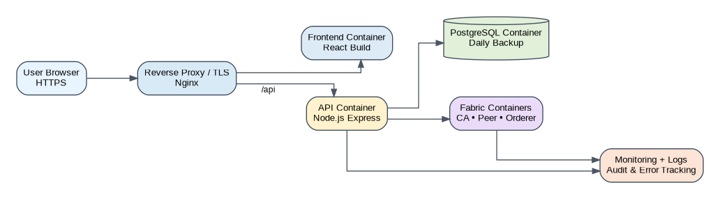
Figure 7. Proposed container-based deployment view.
A Docker-based deployment is recommended because the system has multiple services: frontend, backend API, PostgreSQL, Hyperledger Fabric CA, peer, orderer, and supporting monitoring/logging components. For a first version or demonstration, all services can run in a controlled development server. For production, the database, backup storage, TLS certificates, and Fabric crypto material should be managed more carefully.

19. Development Methodology
Phase | Activities | Deliverables
Phase 1: Requirement Analysis | Study invoice process, user roles, journal rules, payment verification process, and required financial fields. | Requirement specification and approved workflow.
Phase 2: System Design | Design architecture, database, API, UI screens, status workflow, security controls, and chaincode structure. | System design document, diagrams, ERD, API plan.
Phase 3: Development | Build frontend, backend API, database schema, authentication, payment module, audit logs, and Fabric integration. | Working prototype and source code.
Phase 4: Testing | Test duplicate prevention, status update, blockchain commit, login security, search, reports, and audit trail. | Test report and fixed defects.
Phase 5: Deployment and Training | Deploy system, configure users, prepare backups, and train employees/verifiers/admins. | Live system, user guide, admin guide.
Phase 6: Review and Improvement | Collect feedback, monitor errors, and plan enhancements such as analytics or accounting-system integration. | Improvement backlog and version roadmap.

20. Testing Plan
Test Area | Example Test Case | Expected Result
Login and Roles | Employee tries to access payment verification page. | Access denied unless user has verifier/admin role.
Invoice Entry | Employee submits complete invoice with new journal number. | Invoice saved successfully as Pending or Unpaid.
Duplicate Journal | Employee submits an already used journal number. | System blocks submission and shows clear warning.
Payment Update | Verifier changes status from Pending to Paid with payment reference. | Status saved and audit log created.
Blockchain Commit | Paid invoice is submitted to Fabric. | Fabric transaction ID returned and stored in database.
Pending/Unpaid Rule | Pending or Unpaid invoice is submitted to Fabric. | System rejects blockchain submission.
Audit Trail | Verifier updates status and admin reviews invoice history. | All actions show actor, date, action type, and remarks.
Search | User searches by journal number, status, or client name. | Matching records appear correctly.
Security | Expired/invalid token calls protected API. | Request is rejected.
Correction | Committed invoice requires correction. | New correction record is added; original ledger record remains.

21. Risks, Limitations, and Mitigation
Risk / Limitation | Impact | Mitigation
Wrong payment verification before marking Paid | Incorrect information may be committed to blockchain. | Require verifier role, evidence fields, audit review, and correction/reversal process.
Employees enter incomplete or poor-quality data | Reports and audits become unreliable. | Use mandatory fields, dropdowns, validation, and training.
Fabric setup complexity | Deployment and maintenance may require technical expertise. | Start with a simple single-organization Fabric network for demo, then expand later.
Sensitive data on blockchain | Private information may become difficult to remove. | Store only summary data or hashes on Fabric; keep full details in PostgreSQL.
Database or server failure | System downtime or data loss. | Use backups, restore testing, server monitoring, and deployment documentation.
Role misuse or unauthorized status changes | Audit trust may weaken. | Enforce RBAC, log all changes, and review unusual activity.

22. Suggested Implementation Timeline
Week | Focus | Main Output
1 | Requirement confirmation and field finalization. | Approved workflow and data field list.
2 | UI wireframes, database schema, and API design. | Design pack and prototype screens.
3-4 | Frontend and backend invoice module development. | Invoice entry, validation, dashboard, and search.
5 | Payment verification, audit log, and reports. | Status workflow and audit timeline.
6 | Hyperledger Fabric network and chaincode setup. | Fabric test network and paid invoice chaincode.
7 | Integration between backend and Fabric Gateway. | Paid invoice commit and Tx ID storage.
8 | Testing, bug fixing, training materials, and deployment. | Tested system and user/admin guide.

23. Expected Results
- A working web-based invoice form for structured employee data entry.
- Automatic prevention of duplicate journal numbers.
- Clear status tracking using Paid, Unpaid, and Pending categories.
- A controlled verification process where only authorized staff can confirm payment status.
- Hyperledger Fabric storage for verified paid invoice summaries only.
- Improved audit trail showing employee actions and blockchain transaction references.
- Reduced confusion about who sent payment and whether the invoice is settled.
- Better management of Bhutanese and foreign client invoice records.
- Improved accuracy and traceability for financial and project-cost data.
- A scalable foundation for future reporting, analytics, and accounting integration.

24. Significance of the Project
This project is significant because it directly addresses payment uncertainty, duplicate journal numbers, and weak invoice traceability. By separating invoice data entry from payment verification, the organization gains stronger internal control. By using Hyperledger Fabric for verified paid records, the system adds a permissioned and tamper-resistant audit layer that supports accountability and review.
The system also improves employee productivity because invoice records, client details, financial data, payment status, and blockchain references are managed from one website instead of scattered spreadsheets or manual records.

25. Conclusion
This proposal recommends a blockchain-based invoice management and payment authentication system where employees first enter invoice and financial data using a web form, and authorized staff later verify payment status. When a payment is confirmed as Paid and the journal number is valid, the system records a paid invoice summary on Hyperledger Fabric. Unpaid and Pending invoices remain in PostgreSQL until they are verified.
Node.js with Express.js provides a practical backend for APIs, validation, authentication, and Fabric Gateway integration. PostgreSQL provides reliable structured storage for operational data, while Hyperledger Fabric provides a permissioned immutable ledger for verified paid invoice summaries. Overall, the proposed system will reduce duplicate entries, improve payment tracking, and create a trusted audit trail for invoice management.

References
Hyperledger Foundation. (2026). Hyperledger Fabric documentation: A blockchain platform for the enterprise. https://hyperledger-fabric.readthedocs.io/
IBM. (2026). Hyperledger Fabric support documentation. https://www.ibm.com/docs/en/hlf-support/
IBM. (2026). What is blockchain? IBM Think. https://www.ibm.com/think/topics/blockchain
PostgreSQL Global Development Group. (2026). PostgreSQL: About. https://www.postgresql.org/about/
PostgreSQL Global Development Group. (2026). PostgreSQL documentation: Transactions. https://www.postgresql.org/docs/current/tutorial-transactions.html
Tiwari, A. K. (2023). Determinants of electronic invoicing technology adoption. Journal of Open Innovation: Technology, Market, and Complexity.
Han, H., Shiwakoti, R. K., Jarvis, R., Mordi, C., & Botchie, D. (2023). Accounting and auditing with blockchain technology and artificial intelligence: A literature review. International Journal of Accounting Information Systems.

Appendix A: Proposed Minimum Viable Product (MVP)
MVP Feature | Included in First Version
Login and roles | Yes
Invoice entry form | Yes
Duplicate journal validation | Yes
Payment status update | Yes
Audit log | Yes
PostgreSQL storage | Yes
Hyperledger Fabric paid invoice commit | Yes
Dashboard and search | Yes
Advanced analytics | Later
Bank API integration | Later

